ANDREW JACKSON HIGH SCHOOL
100 YEAR CELEBRATION
APRIL 24, 2027

Donation Form

PLEASE PROVIDE THE FOLLOWING INFO:

Name ________________________________________________________
Address______________________________________________________________
Phone_______________________________
E-mail_______________________________________________
Amount of contribution $_________
Would you like your name in the program with our list of donors YES___ NO___

Please make check payable to AJHS 100 YEAR CELEBRATION.
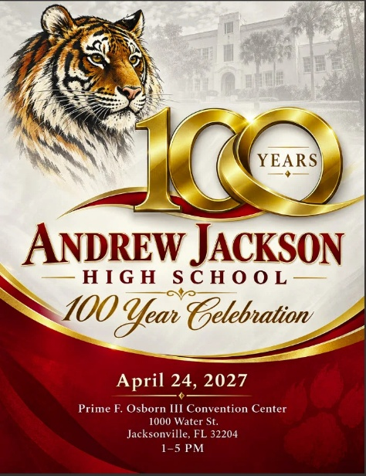
Mail this form and check to:
Debbie Jones
54051 Corley Dr
Callahan, FL 32011

For further information contact:
Debbie Jones 904-699-9380 jonesdebken@att.net

Thank you for your support!

(Volunteer Donation is not tax deductible as charitable contribution)

