ANDREW JACKSON HIGH SCHOOL
100 YEAR CELEBRATION
APRIL 24, 2027
Advertising Agreement Form

We are soliciting advertisements that will be included in a program for the AJHS 100 YEAR CELEBRATION to be given out to all attendees of this event. The money received for the ads will be used to defray the cost of this celebration.

PLEASE SELECT AD SIZE AND COMPLETE THE INFORMATION REQUESTED BELOW.
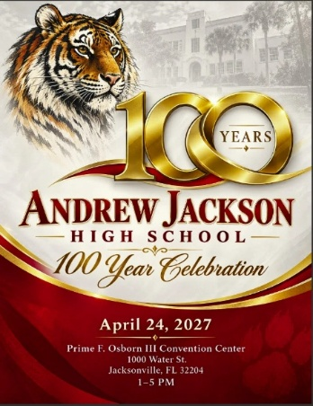

Check ad size:

        - Business card $25.00
        - ¼ page $35.00
        - ½ page $60.00
        - Full page $100.00
        - Inside color front/back cover $175.00

Name of Business____________________________________________________________________
Owner Name________________________________________________________________________
Address____________________________________________________________________________
Phone___________________________
E-mail___________________________________________________
AMOUNT $ _______________

NOTE: You must submit a business card or a camera-ready copy of the ad to be displayed in the program.

Please make check payable to AJHS 100 YEAR CELEBRATION.
Mail this form, your business card/camera-ready copy, and check to:
Debbie Jones
54051 Corley Dr
Callahan, FL 32011

Each person placing an ad will receive a copy of the program.

For further information contact:
Debbie Jones 904-699-9380 jonesdebken@att.net

Thank you for your support!

